Connecting to Eduroam Wi-Fi (Mobile Phone)

A users Guide to connecting to Eduroam Wi-Fi using a mobile phone

Eduroam is a private Wi-Fi service that allows anyone to connect to it anywhere in the world that supports it, providing they have a profile through an academic institution such as a school, college or university. Once connected once it allows you to connect to it via Wi-Fi seamlessly to any Eduroam access point in the world.

This tutorial will guide you through the process of connecting to the Eduroam service for the first time.

You will require:

* A Wi-Fi Capable Device
* An Eduroam Profile

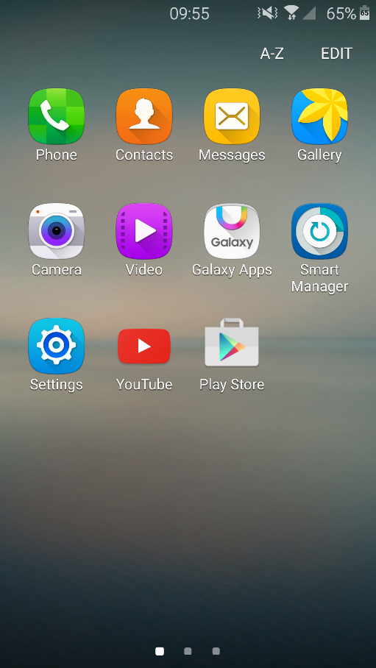

# Step 1

The first step is the most simple. On your mobile device, navigate to your applications and find the settings area as shown in the image on the right. Your icon may differ slightly from mine, however the button you are looking for should take you to your device settings.

You can confirm you are on the correct section by looking at the available option to you. If you have things like Wi-Fi, Data Usage and Display settings then you are on the right section.

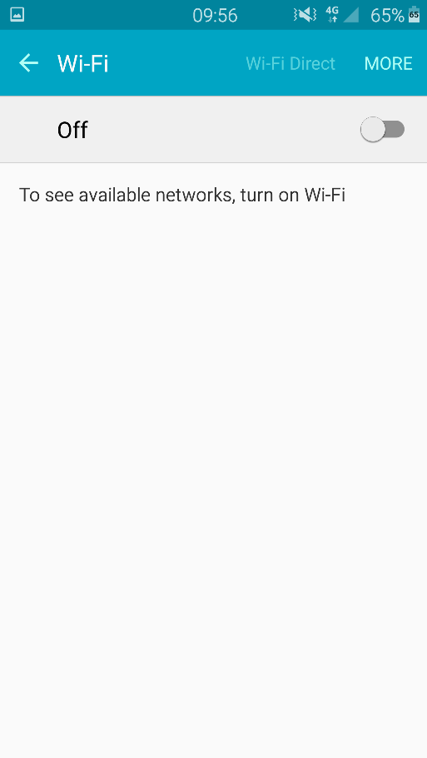

# Step 2

Once on the settings menu, navigate to the setting section that says “Wi-Fi”. You should be presented with a screen that looks like this one on the left. If your Wi-Fi is already turned on then move onto step 3. If your Wi-Fi is not turned on then simple click the slide button that is shown in the image on the left and wait for your device Wi-Fi to detect all the available Wi-Fi access points available to you.

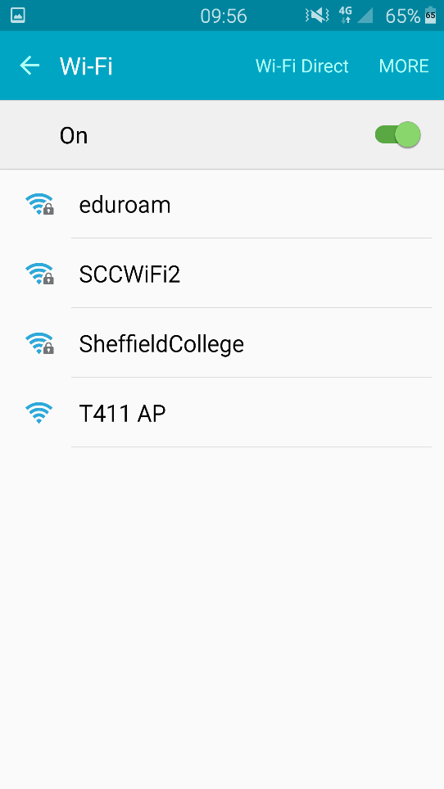

# Step 3

Now you have turned Wi-Fi on, you should be able to see the available wireless networks in your area. Look for the one named “Eduroam” and click it once to connect. If you are prompted with a screen asking you if you want to connect, click either “yes” or “connect”.

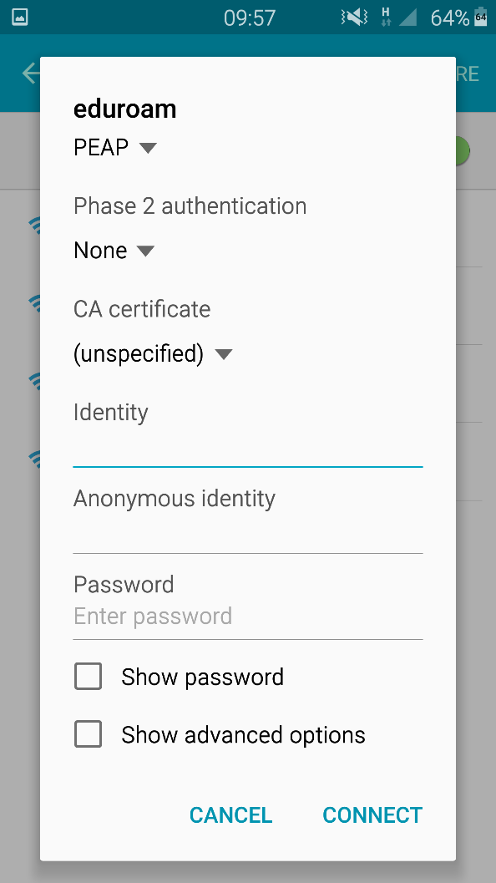

# Step 4

You should now be faced with this menu, click in the drop down box under the phase 2 section and select “MSCHAPV2”. Next select the textbox under identity and enter your Eduroam ID. You id will be your student number followed by the institution you are attending. EG: [**427075@sheffcol.ac.uk**](mailto:427075@sheffcol.ac.uk)

Next select the text box under the password section (make sure to leave the anonymous identity section blank) enter your password which should be the exact same password you use to login to your institution. For example this may be your login for your institution’s computer systems.

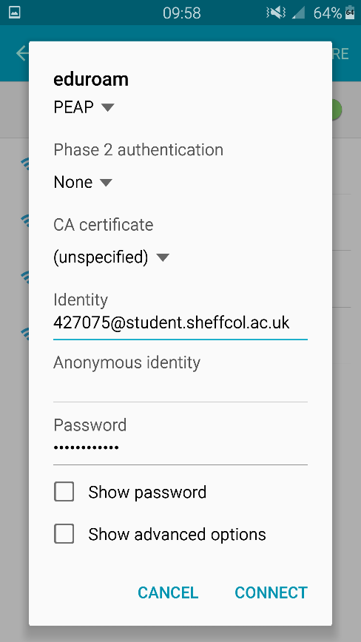

# Step 5

You should now have something that looks like this. Ensure you have entered all your details correctly. If you are 100% sure that all your details are correct, click the “connect” button on the screen.

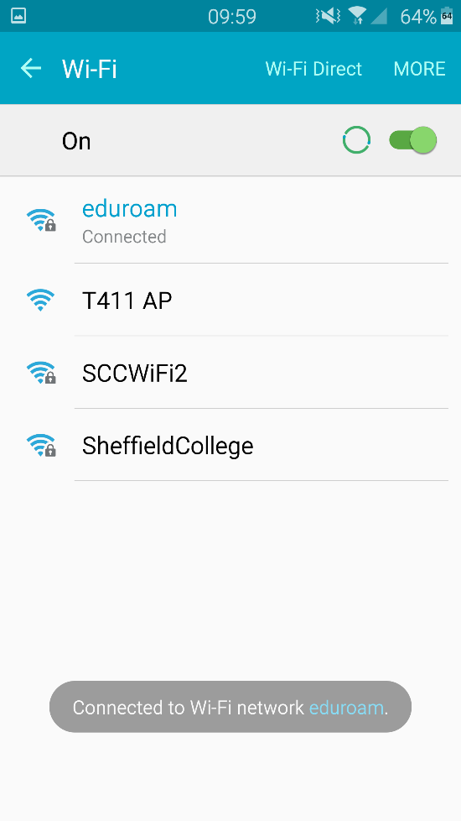

# Step 6

If all your details are correct and you have an account on the Eduroam system then you should now be connected to the Eduroam Wi-Fi network.

# FAQ

## It’s not accepting my details?

This problem may be caused by the incorrect entrance of your ID and PASSWORD. If you are still having issues then please contact your institution and check if you have an account for the Eduroam service.

## What Devices can I use?

You can use any device that has Wi-Fi capabilities. You can check if you device has Wi-Fi capabilities by checking the manufacturer website for your device or, you can check by looking in the settings for a Wi-Fi option.

## Where can I use it?

You can use Eduroam at any institution such as schools, colleges or universities that support the service. For a full list of Eduroam access points, look here: <https://www.jisc.ac.uk/eduroam>

### References:

Website: <https://www.jisc.ac.uk/eduroam>  
Email: [customerservices@jisc.ac.uk](mailto:customerservices@jisc.ac.uk)  
Phone: 0203 006 6077 (Customer Services)  
Free Phone: 0300 300 2212 (Network Enquiries)